PSG COLLEGE OF TECHNOLOGY-COIMBATORE
DEPARTMENT OF APPLIED MATHEMATICS AND COMPUTATIONAL SCIENCES
III Sem MSc Software Systems - 18XW38 - RDBMS LAB
Problem Sheet – II

- Create an EMPTABLE with the following fields and constraints.

Field Name data type width Constraint Description

Empid numeric 6 Primary key Employee id
Name character 10 not null, Starts with uppercase
City character 10 Starts with uppercase
DoB date not null Date of birth
Sex character 1 F or M
DoJ date not null Date of joining
Salary numeric 8, 2 between 15000 and 50000
Department character 10 ACC or FIN or EDP

CREATE TABLE emptable
( Empid int(6),
Name varchar(10) NOT NULL,
City varchar(10),
DoB date NOT NULL,
Sex varchar(1),
DoJ date NOT NULL,
Salary double(8, 2),
Department varchar(10),
PRIMARY KEY(Empid),
CONSTRAINT n_uppercase CHECK (ASCII(LEFT(Name, 1)) BETWEEN ASCII('A') and ASCII('Z')),
CONSTRAINT c_uppercase CHECK (ASCII(LEFT(City, 1)) BETWEEN ASCII('A') and ASCII('Z')),
CONSTRAINT s_values CHECK (Sex='F' or Sex='M'),
CONSTRAINT s_between CHECK (Salary>=15000 and Salary<=50000),
CONSTRAINT d_values CHECK (Department='ACC' or Department='FIN' or Department='EDP')
);

- INSERT the following data into the EMPTABLE table.
Note: SQL date format YYYY-MM-DD

Empid | Name | City | DoB | Sex | DoJ | Salary | Department
1001 | Anish | Chennai | 21-apr-66 | M | 10-jun-86 | 17000 | ACC
1002 | Anandi | Ooty | 11-sep-75 | F | 17-jun-97 | 15000 | FIN
1003 | Shiva | Kambam | 07-feb-66 | M | 21-apr-91 | 21000 | EDP
1004 | Deepa | Trichi | 14-feb-67 | M | 21-apr-90 | 12000(failed)  15000 | FIN
1005 | Engela |  | 23-mar-70 | F | 21-apr-86 | 32000 | EDP
1006 | Krish | Trichi | 14-jul-70 | F | 21-mar-89 | 15000 | ACC
1007 | Kamal | Ooty | 14-jul-66 | M | 04-mar-90 | 12000(failed)  15000 | FIN
1008 | Neela | Madurai | 27-jun-69 | F | 07-apr-90 | 25000 | EDP
1009 | Bala | Coimbatore | 29-oct-62 | M | 21-apr-93 | 20000 | ACC
1010 | Rajesh | Pollachi | 21-apr-66 | M | 12-oct-93 | 17000 | FIN
1011 | Rekha | Coimbatore | 21-apr-70 | F | 14-dec-99 | 20000 | ACC
1012 | Xavier | Madurai | 21-apr-71 | M | 12-mar-97 | 20000 | ACC
1013 | Vinotha | Trichi | 21-apr-72 | F | 21-apr-94 | 17000 | ACC

INSERT INTO `emptable`(`Empid`, `Name`, `City`, `DoB`, `Sex`, `DoJ`, `Salary`, `Department`)
VALUES (1001, 'Anish', 'Chennai', '1966-04-21', 'M', '1986-06-10', 17000, 'ACC'),
(1002, 'Anandi', 'Ooty', '1975-09-11', 'F', '1997-06-17', 15000, 'FIN'),
(1003, 'Shiva', 'Kambam', '1966-02-07', 'M', '1991-04-21', 21000, 'EDP'),
(1004, 'Deepa', 'Trichi', '1967-02-14', 'M', '1990-04-21', 12000, 'FIN'),
(1005, 'Engela', null,'1970-03-23', 'F', '1986-04-21', 32000, 'EDP'),
(1006, 'Krish', 'Trichi', '1970-07-14', 'F', '1989-03-21', 15000, 'ACC'),
(1007, 'Kamal', 'Ooty', '1966-07-14', 'M', '1990-03-04', 12000, 'FIN'),
(1008, 'Neela', 'Madurai', '1969-06-27', 'F', '1990-04-07', 25000, 'EDP'),
(1009, 'Bala', 'Coimbatore', '1962-10-29', 'M', '1993-04-21', 20000, 'ACC'),
(1010, 'Rajesh', 'Pollachi', '1966-04-21', 'M', '1993-10-12', 17000, 'FIN'),
(1011, 'Rekha', 'Coimbatore', '1970-04-21', 'F', '1999-12-14', 20000, 'ACC'),
(1012, 'Xavier', 'Madurai', '1971-04-21', 'M', '1997-03-12', 20000, 'ACC'),
(1013, 'Vinotha', 'Trichi', '1972-04-21', 'F', '1994-04-21', 17000, 'ACC');
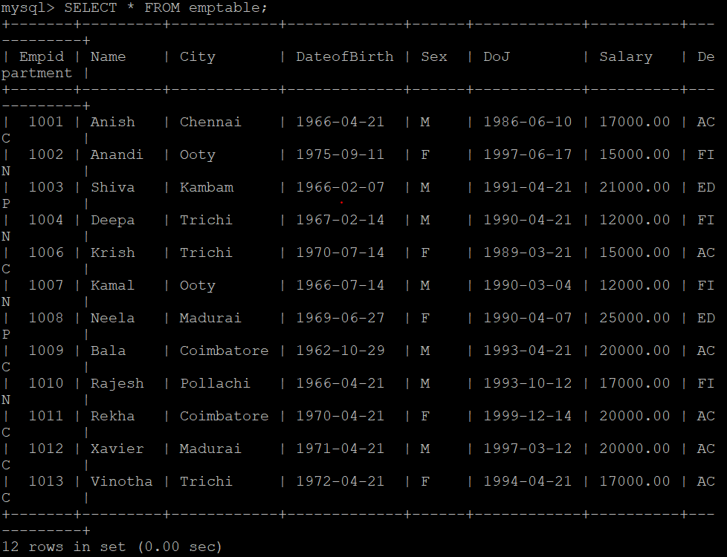

- Answer the following queries by writing SQL statements.

  - Display all the details of all the employees.
SELECT * FROM `emptable`;
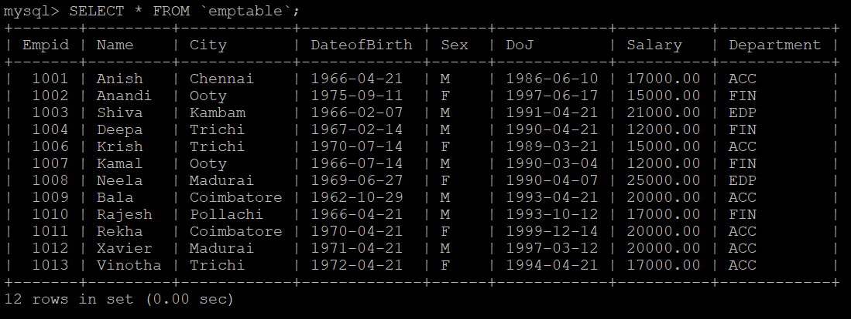
  - Display each employee's id, name, city and salary.
SELECT `Empid`, `Name`, `City`, `Salary` FROM `emptable`;
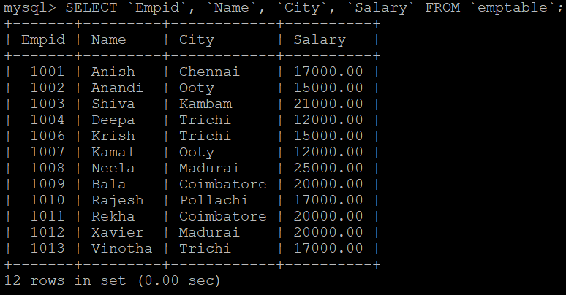
  - Display the employee id of the employee “Bala”.
SELECT `Empid` FROM `emptable` WHERE Name = 'Bala';
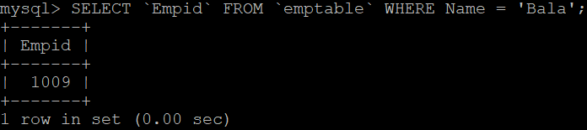
  - List all the details of male employees.
SELECT * FROM `emptable` WHERE Sex='M';
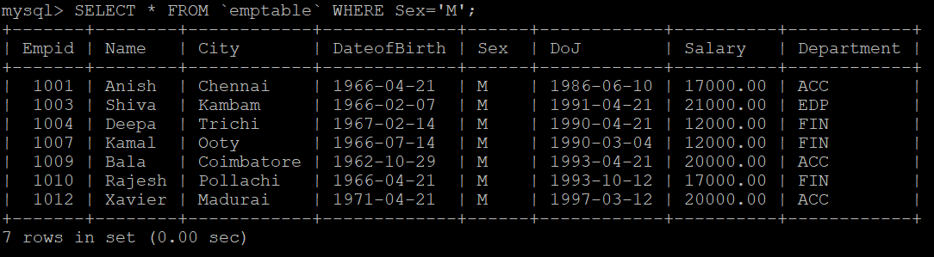
  - Display the details of the employees from Coimbatore.
SELECT * FROM `emptable` WHERE City='Coimbatore';
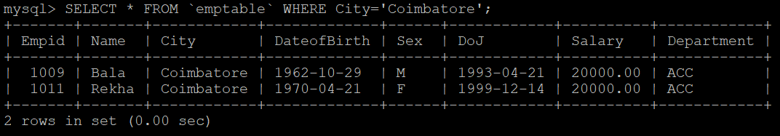
  - Display the details of the employees from Coimbatore, Trichi and Chennai.
SELECT * FROM `emptable` WHERE City IN ('Coimbatore', 'Trichi', 'Chennai');
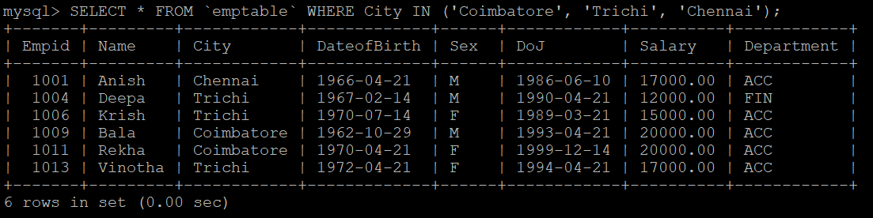
  - Display the name of the employee whose city name is not stored in the EMPTABLE.
SELECT `Name` FROM `emptable` WHERE City IS NULL;
  - Display all the cities of the employees.
SELECT DISTINCT(City) FROM emptable;
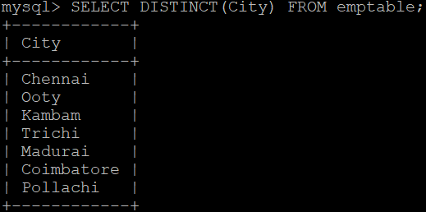
  - Display the employee id with the salary value doubled.
SELECT Empid, Salary*2 AS Double_Salary FROM emptable;
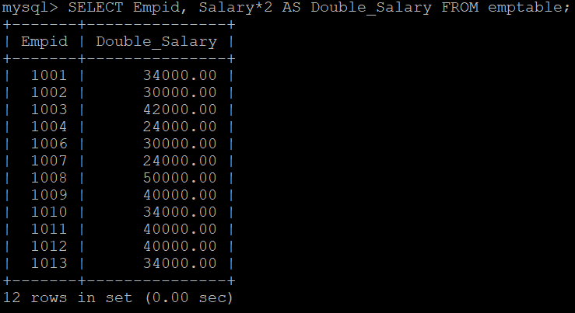
  - Display name, city and department of employees earning more than 50000.
SELECT Name, City, Department FROM emptable WHERE Salary > 50000;
  - Display employee's id, name and salary with a 5% increase under a heading "increased salary".
Note: Alias must be given in “ “ in AS and `` in clauses such as group by/order by.
SELECT Empid, Name, Salary*105/100 AS "Increased Salary" FROM emptable;
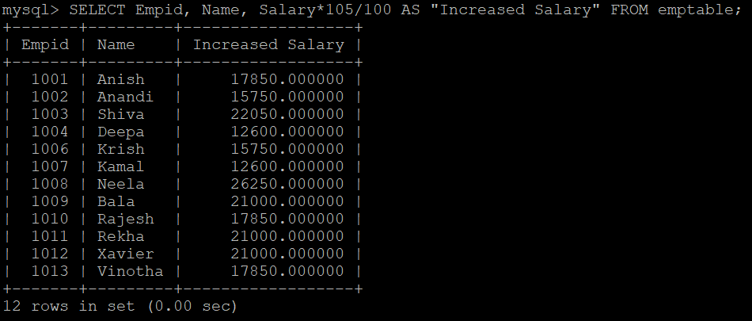
  - Modify the above query so that it lists employees from the highest "increased salary" to the lowest.
SELECT Empid, Name, Salary*105/100 AS "Increased Salary" FROM emptable ORDER BY `Increased Salary` DESC;
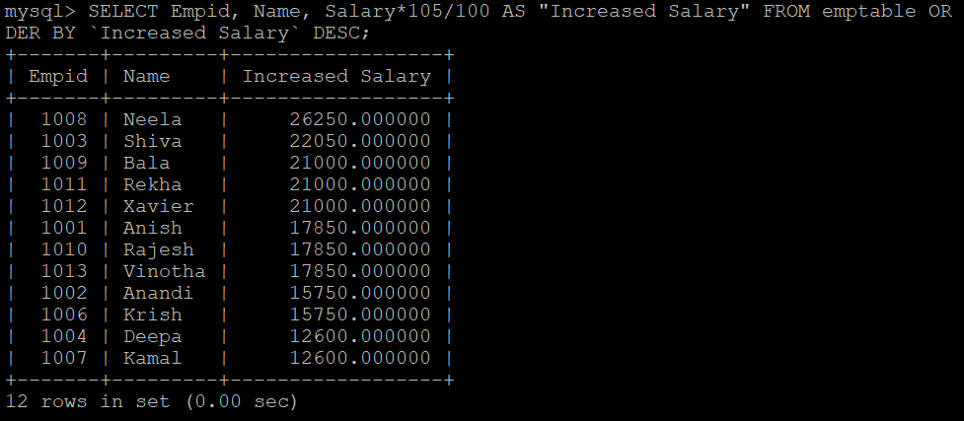
  - Sort and display the details by name in ascending order and salary in descending order.
SELECT * FROM emptable ORDER BY Name, Salary DESC;
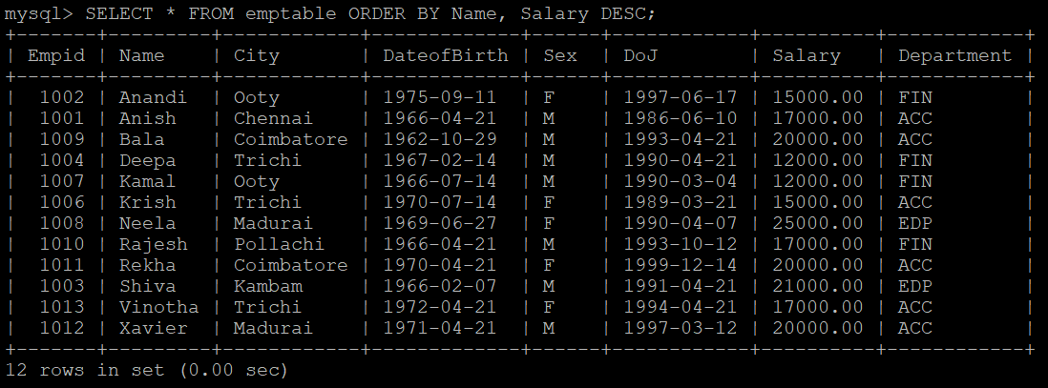
  - Display the number of employees.
SELECT Count(*) FROM emptable;
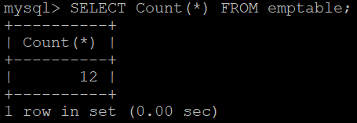
  - Count the number of departments in the EMPTABLE.
SELECT Count(DISTINCT(Department)) FROM emptable;
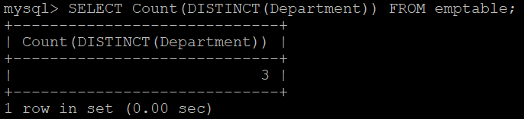
  - Display the number of employees in FIN department.
SELECT COUNT(*) FROM emptable WHERE Department='FIN';
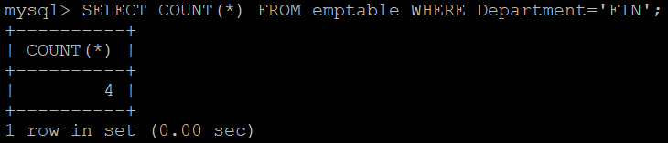
  - Find the number of male employees.
SELECT COUNT(*) FROM emptable WHERE Sex='M';
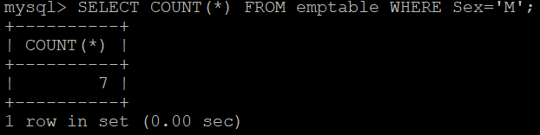
  - Display name of employee earning highest salary.
SELECT Name FROM emptable WHERE Salary = (SELECT MAX(Salary) FROM emptable);
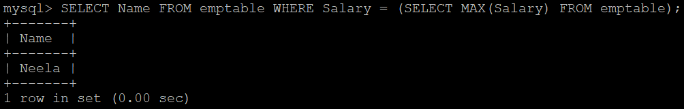
  - Display name of employee earning lowest salary.
SELECT Name FROM emptable WHERE Salary = (SELECT MIN(Salary) FROM emptable);
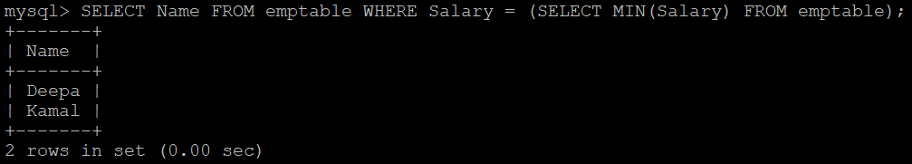
  - Display sum of salary of employees in each department.
SELECT Department, SUM(Salary) FROM emptable GROUP BY Department;
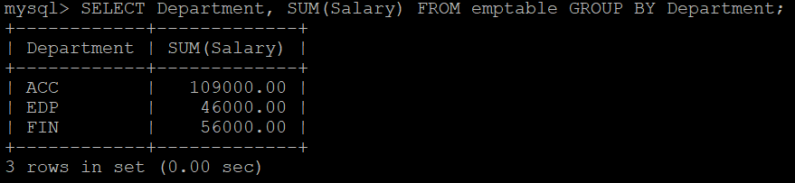
  - List the Empids of all employees except 1002.
SELECT Empid FROM emptable WHERE Empid<>1002;
Or SELECT Empid FROM emptable WHERE Empid!=1002;
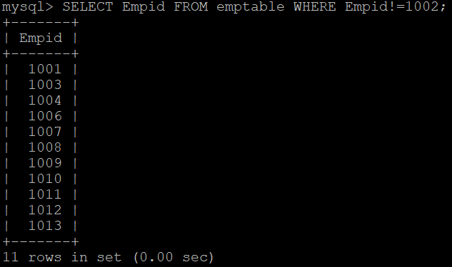
  - Display details of employees whose names start with 'A'.
SELECT * FROM emptable WHERE Name LIKE 'A%';
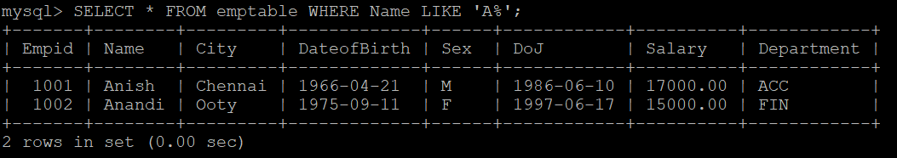
  - Show the details of employees who have born before 01-jan-91.
SELECT * FROM emptable WHERE DoB < '1991-01-01';
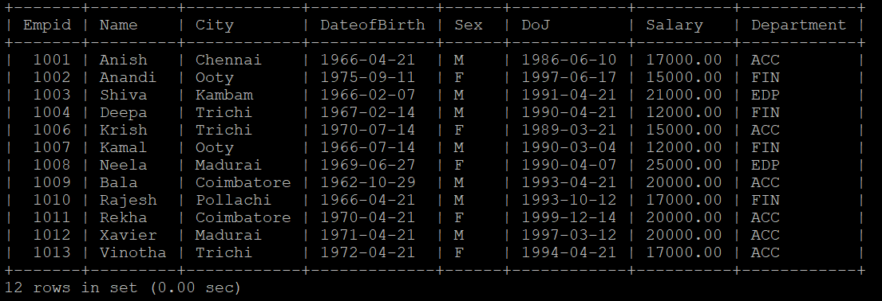
  - Display name of employees whose salaries are between 20000 and 40000.
SELECT Name FROM emptable WHERE Salary>=20000 and Salary<=40000;
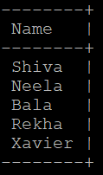
  - Show the details of the employees earning more than 20000.
SELECT * FROM emptable WHERE Salary>20000;
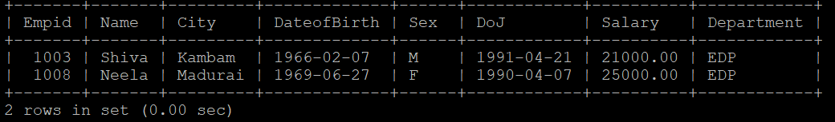
  - Show the details of the employees earning more than 20000 in the department ACC.
SELECT * FROM emptable WHERE Salary>20000 and Department='ACC';
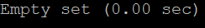
  - Show the details of the employees earning more than 20000 in each department.
SELECT COUNT(*) FROM emptable WHERE Salary>20000 GROUP BY Department;
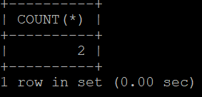
  - Display employees name and the lowest salary earned by them in each department
SELECT Name, MIN(Salary), Department FROM emptable GROUP BY Department;
OR
SELECT Name, Salary, Department FROM emptable WHERE (Department, Salary) IN (SELECT Department, MIN(Salary) FROM emptable GROUP BY Department);
  - Find the number of male employees department wise.
SELECT COUNT(*), Department FROM emptable WHERE Sex='M' GROUP BY Department;
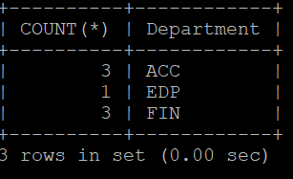
  - Display the experience of each employee in days.
SELECT Empid, Name, DATEDIFF(CURDATE(), DoJ) AS Experience_days FROM emptable;
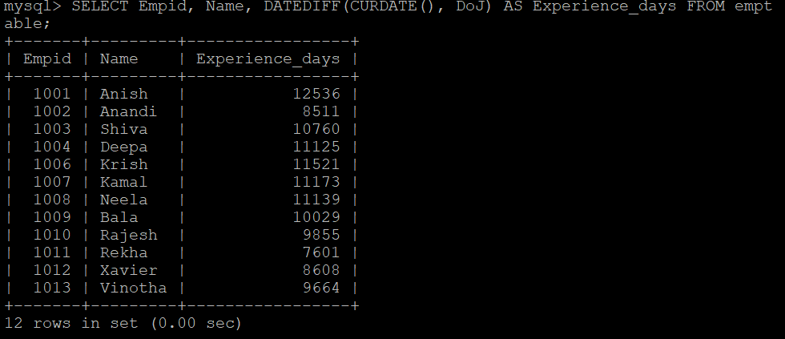
  - Display the experience of each employee in years.
SELECT Empid, Name, DATEDIFF(CURDATE(), DoJ)/365 AS Experience_years FROM emptable;
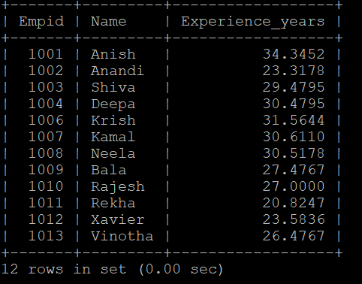
  - Display name and age of all employees.
SELECT Name, DATEDIFF(CURDATE(), DoB)/365 as AGE FROM emptable;
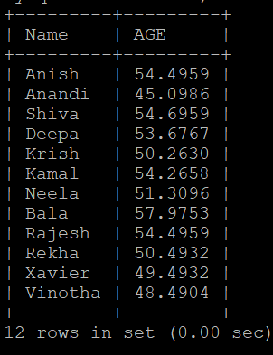
  - Display the employee who is the oldest.
SELECT * FROM emptable WHERE DoB = (SELECT MIN(DoB) FROM emptable);
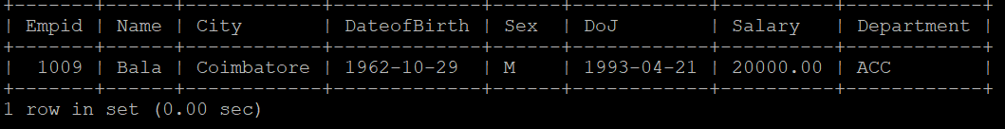
  - How old is the oldest employee?
SELECT DATEDIFF(CURDATE(), MIN(DoB))/365 AS AGE FROM emptable;
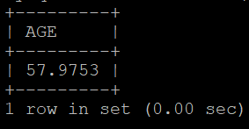
  - Display names, city of employees in alphabetical order.
SELECT Name, City FROM emptable ORDER BY Name, City;
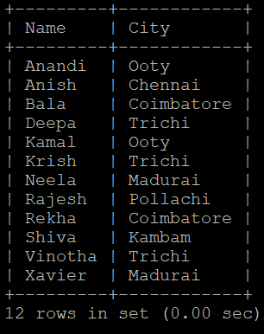
  - Display name, date of birth of employees born in January.
SELECT Name, DoB FROM emptable WHERE MONTH(DoB)='01';
  - Display the number of employees working in each department.
SELECT Department, COUNT(*) FROM emptable GROUP BY Department;
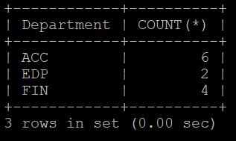
  - Display the number of employees working in each department.
SELECT Department, COUNT(*) FROM emptable GROUP BY Department;
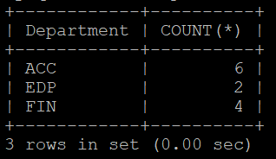
  - What is the average age of the male and female employees?
SELECT Sex, AVG(DATEDIFF(CURDATE(), DoB)/365) AS AVERAGE_AGE FROM emptable GROUP BY Sex;
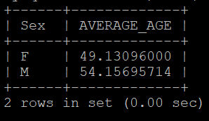
  - Who are the employees who celebrate their birthdays in the current month?
SELECT * FROM `emptable` WHERE MONTH(DoB) = MONTH(CURDATE());
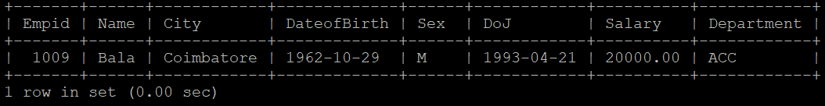
  - What is the average salary?
SELECT AVG(Salary) FROM emptable;
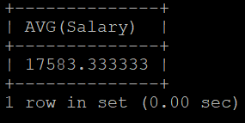
  - What is the average salary in each department?
SELECT Department, AVG(Salary) FROM emptable GROUP BY Department;
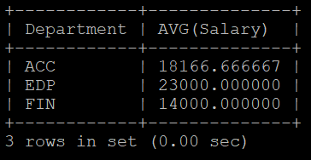
  - Find the sum of salaries in each department
SELECT Department, SUM(Salary) FROM emptable GROUP BY Department;
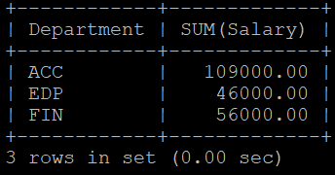
  - How many employees earn more than 30000?
SELECT COUNT(*) FROM emptable WHERE Salary>30000;
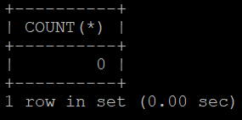
  - Find the maximum salary.
SELECT MAX(Salary) FROM emptable;
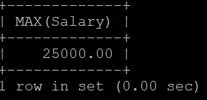
  - Find the maximum salary in each department.
SELECT Department, MAX(Salary) FROM emptable GROUP BY Department;
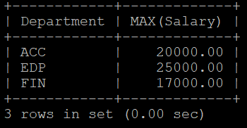
  - How many female employees are coming from Coimbatore?
SELECT COUNT(*) FROM emptable WHERE Sex='F' AND City='Coimbatore';
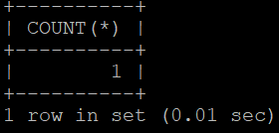
  - Display details of those who weren't born in October and March
SELECT * FROM emptable WHERE MONTH(DoB) NOT IN ('03', '10');
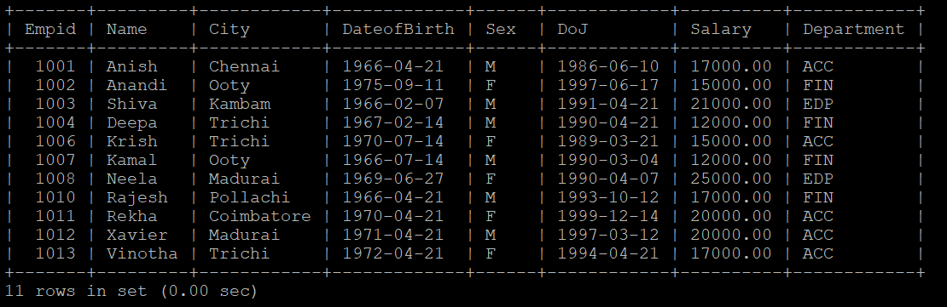
  - Display each department with number of female employees.
SELECT Department, COUNT(*) FROM emptable WHERE Sex='F' GROUP BY Department;
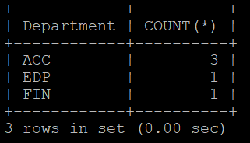
  - Display employee's name, city and dob in any order.
SELECT Name, City, DoB FROM emptable;
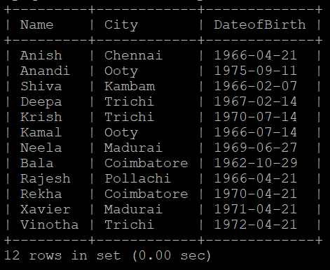
  - Display salary difference between highest and lowest salary.
SELECT MAX(Salary)-MIN(Salary) FROM emptable;
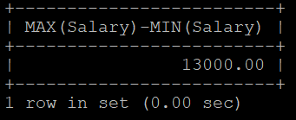
  - Display the department with employees coming from more number of cities.
SELECT Department FROM emptable GROUP BY Department ORDER BY Count(City) DESC LIMIT 1;
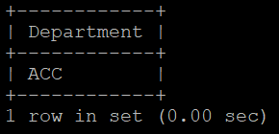
  - Which department has lowest no of employees?
SELECT Department FROM emptable GROUP BY Department ORDER BY Count(*) LIMIT 1;
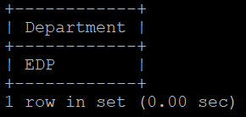
  - Who is the youngest male employee born in 1990?
SELECT * FROM emptable WHERE DoB = (SELECT MAX(DoB) FROM emptable WHERE YEAR(DoB)='1990' and Sex='M');
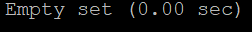
  - Who is the oldest female employee born in 1990?
SELECT * FROM emptable WHERE DoB = (SELECT MIN(DoB) FROM emptable WHERE YEAR(DoB)='1990' and Sex='F');
  - Display names all the employees who are less than 32 years old.
SELECT Name FROM emptable WHERE DATEDIFF(CURDATE(), DoB)/365 < 32;
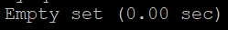
  - List the details of all employees who are younger than the employee with employee id 1007.
SELECT * FROM emptable WHERE DoB > (SELECT DoB FROM emptable WHERE Empid = 1007);
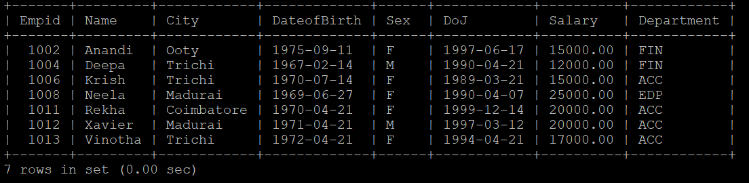
  - In which year was the most number of employees born?
SELECT YEAR(DoB) FROM emptable GROUP BY YEAR(DoB) ORDER BY COUNT(*) DESC LIMIT 1;
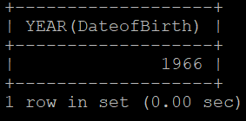
  - In which month was the most no. of employees born?
SELECT MONTH(DoB) FROM emptable GROUP BY MONTH(DoB) ORDER BY COUNT(*) DESC LIMIT 1;
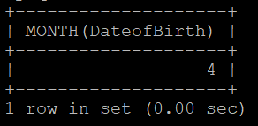
  - Who are the male employees earning below the average salary of female employees?
SELECT * FROM emptable WHERE Sex = 'M' AND Salary < (SELECT AVG(Salary) FROM emptable WHERE Sex = 'F');
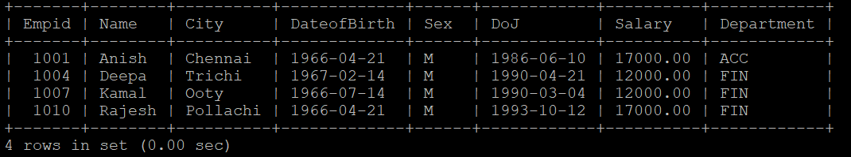
  - Display details of those who are drawing the same salary?
SELECT * FROM emptable WHERE Salary = ANY (SELECT Salary FROM emptable e GROUP BY Salary HAVING e.Salary = Salary AND COUNT(*) > 1) ORDER BY Salary;
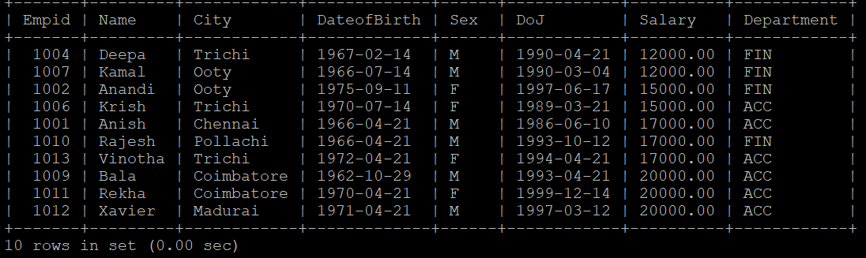
  - How many different departments are there in the table?
SELECT COUNT(DISTINCT(Department)) FROM emptable;
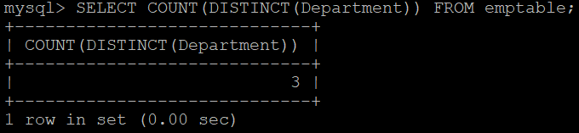
  - Display names of employees whose names contain up to 5 characters.
SELECT Name FROM emptable WHERE LENGTH(Name) <= 5;
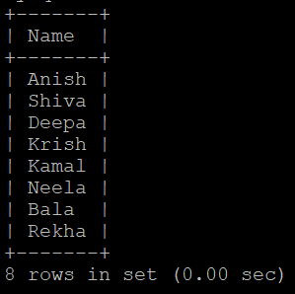
  - Display names of employees whose names contain occurrences of the letter 'e'
SELECT Name FROM emptable WHERE Name LIKE '%e%';
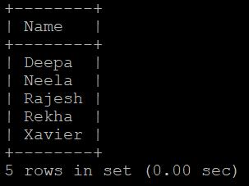
  - Display the details of employees coming from the city ‘Trichi’ and are working in different
departments.
SELECT * FROM emptable WHERE City = 'Trichi';
OR
SELECT * FROM emptable WHERE City='Trichi' AND Department = ANY(SELECT Department FROM emptable e WHERE City='Trichi' GROUP BY Department HAVING COUNT(*) = 1);
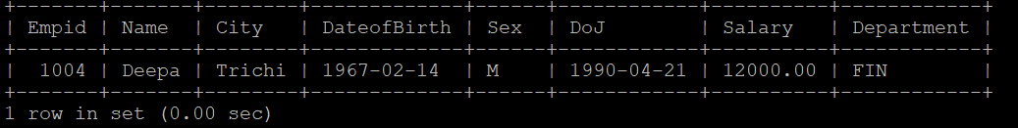
  - Display the details of employees arranged in the order of their cities.
SELECT * FROM emptable ORDER BY City;
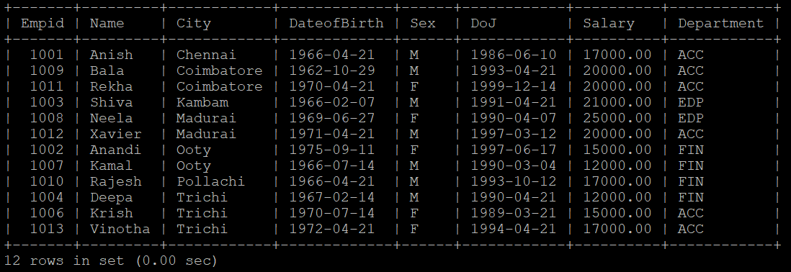
  - Display the city and the number of employees from each city.
SELECT City, COUNT(*) FROM emptable WHERE City!='null' GROUP BY City;
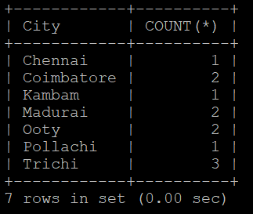
  - Display the employees who are from same city and earn the same salary.
SELECT * FROM emptable WHERE (City,Salary) = ANY (SELECT City, Salary FROM emptable e GROUP BY City,Salary HAVING e.Salary = Salary AND e.City = City AND COUNT(*) > 1) ORDER BY Salary;
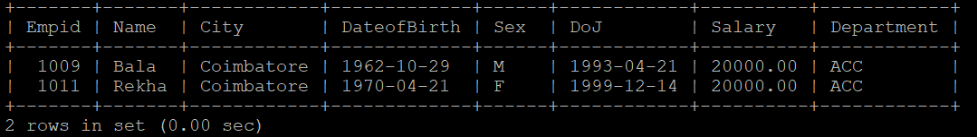
  - Display the department in which there is no employee from Trichy.
SELECT DISTINCT(Department) FROM emptable WHERE Department NOT IN (SELECT Department FROM emptable WHERE City='Trichi');
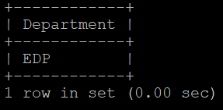
  - Find the employees who work for different departments who earn the same salary.
SELECT * FROM emptable WHERE Salary = ANY (SELECT Salary FROM emptable e GROUP BY Salary HAVING COUNT(*) > 1 AND COUNT(DISTINCT(Department)) > 1 AND COUNT(Department) = COUNT(DISTINCT(Department))) ORDER BY Salary;
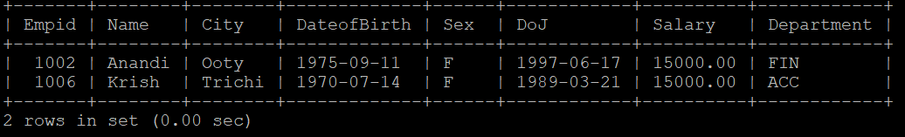
  - Display the female employees who earn the same salary.
SELECT * FROM emptable WHERE Salary = ANY(SELECT Salary FROM emptable e WHERE Sex = 'F' GROUP BY Salary HAVING Salary = e.Salary AND COUNT(*) > 1) ORDER BY Salary;
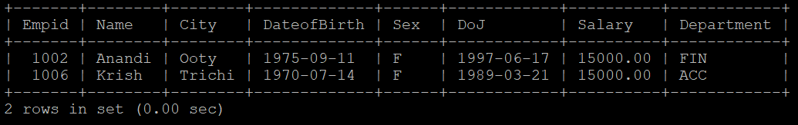
  - Modify the length of the field Name from 10 to 15.
ALTER TABLE emptable MODIFY Name varchar(15);
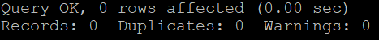
  - Add a new column named age of type numeric with length 3.
ALTER TABLE emptable ADD Age INT(3);
  - Update the data into age by computing the value from DoB.
UPDATE emptable SET Age = DATEDIFF(CURDATE(), DoB) / 365;
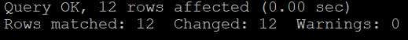
  - Rename the column DoB to DateofBirth.
ALTER TABLE emptable CHANGE COLUMN DoB DateofBirth DATE;
  - Remove the age column from the table.
ALTER TABLE emptable DROP COLUMN Age;
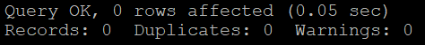
  - Display all the employee details in the following format.
Anish of Acc department comes from Chennai
SELECT Name, 'of', Department, 'comes from', City FROM emptable;
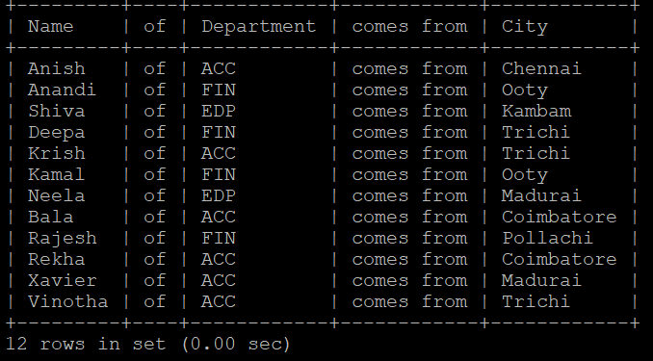
  - What does the following SQL query print?
SELECT fname FROM employee WHERE dept = ‘ACC’ ORDER BY 1 DESC;
Code Correction: SELECT Name FROM emptable WHERE Department = 'ACC' ORDER BY 1 DESC;
ORDER BY 1 = Order by the first column specified in the SELECT column list
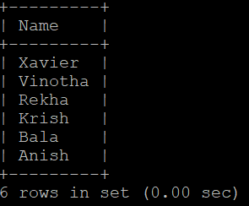
  - Remove the constraint of DoJ.
ALTER TABLE emptable MODIFY DoJ DATE NULL;
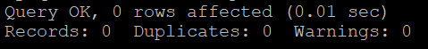
  - Display the names and cities of all the employees in uppercase.
SELECT UPPER(Name), UPPER(city) FROM emptable;
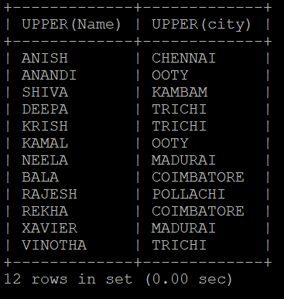
  - In which month was the most number of employees born?
SELECT MONTH(DateofBirth) FROM emptable GROUP BY MONTH(DateofBirth) ORDER BY COUNT(*) DESC LIMIT 1;
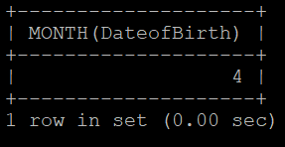
  - Who are the male employees earning below the average salary of the female employees?
SELECT * FROM emptable WHERE Sex = 'M' AND Salary < (SELECT AVG(Salary) FROM emptable WHERE Sex = 'F');
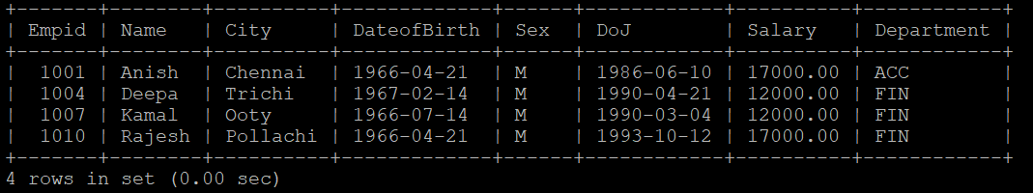
  - Who are the female employees earning more than the highest salary of male employee?
SELECT * FROM emptable WHERE Sex = 'F' AND Salary > (SELECT MAX(Salary) FROM emptable WHERE Sex = 'M');
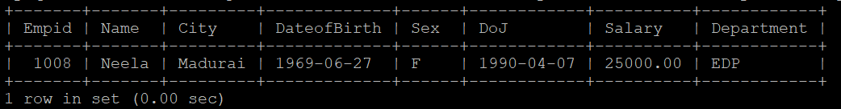
  - Insert a record into EMPTABLE to show violation of primary key constraint.
INSERT INTO emptable(`Empid`, `Name`, `City`, `DateofBirth`, `Sex`, `DoJ`, `Salary`, `Department`) VALUES (1001, 'John', 'Chennai', '2001-11-06', 'M', '2020-09-20', 19000, 'FIN');
  - Remove the record of “Engela” from the EMPTABLE.
DELETE FROM emptable WHERE Name = 'Engela';

